UC Berkeley Accelerator
Origin Story: Why did you decide to create this startup, and how & when did you meet your cofounders?

We’ve known each other for years, meeting in London through childhood friends. We’ve been flatmates for 1.5 years, sharing a close network and a passion for endurance sports (ski mountaineering, gravel biking), building a foundation of absolute trust already before the idea for this start-up emerged.
Throughout our work and research (Robert: at Convergence AI; Tobias: implementing AI tools in research and large organisations), we saw that enterprise agents fail to provide an ROI because they do not learn and do not adapt. We realised we are very well positioned to solve this interesting and economically relevant bottleneck in today’s AI implementation, as we uniquely combine seasoned AI leadership with hardcore execution and organisational experience.
Our technical foundation comes from the forefront of RL research (Robert: AISTATS best paper nominee, led extensive research in RL, first employee and built the R&D team at Convergence AI, acquired by Salesforce). We couple this with executive perseverance (Tobias), highlighted by experience building a 20-30 person team from scratch to successfully manage a $3.3B crisis response.
Hence, we founded Aganthos to provide the "learning layer" that allows agents to actually improve from experience.

What would you like to contribute, or bring, to SkyDeck to make it a better ecosystem and platform for all entrepreneurs?

We are primarily driven by the opportunity to tap into SkyDeck’s deep Silicon Valley network and enterprise connections, whether through the full Accelerator or the Pad-13 incubator program, to rapidly expand our B2B pipeline.

We are eager to embed ourselves within UC Berkeley’s world-class AI community to exchange high-level insights on scaling Reinforcement Learning, and critically, to recruit the high-caliber R&D talent and engineers required to build our core learning layer.

If selected for the main $200K investment track, we will allocate the funds directly toward expanding our core engineering staff, securing the GPU compute necessary for our continuous training loops, and funding our team's rent and operational presence in California during the program.

—

What would you like to contribute, or bring, to SkyDeck to make it a better ecosystem and platform for all entrepreneurs?

Many founders in the ecosystem possess incredible client networks but lack a sophisticated, scalable "Learning as a Service" architecture; we can integrate our learning layer to make their own AI products much more reliable and competitive. We aim to actively collaborate with other B2B SaaS and agent platform founders in the cohort , providing the technical infrastructure to help them overcome the AI "reliability wall".

Beyond technical contributions, we bring deep organizational scaling and high-stakes decision-making expertise , and can share our operational frameworks from building and leading a $2.6B national crisis management team from scratch.

Aganthos AI provides the learning layer for AI agents. We solve the critical "reliability wall" that prevents enterprise agents from scaling and providing actual return on investment. Current agents are static. They behave like interns on day 100 of deployment and make the same mistakes repeatedly. Our learning layer improves agents continuously through Reinforcement Learning (RL). Through that, agents learn from every interaction (logs, traces, human feedback), continuously improving their success rate.

Our platform offers:
1) Continuous Improvement: In a paid pilot partnership, agents achieve +30% better performance than general models (like o4-mini) by learning from specific feedback in a workflow. In this specific use case of a medium to large sized hospital, this has the potential to save 5-15 full time equivalents (>1 Mio Euro).
2) Cost Reduction: We intelligently route tasks to smaller, cheaper models once they are trained, slashing inference costs.
3) Privacy: We support local deployment and knowledge transfer, ensuring sensitive data never leaves the organization.

Our founding team combines deep research expertise with proven operational scalability. Our Lead Researcher has a decade of experience in Reinforcement Learning (RL), was a Founding Research Scientist at Convergence AI (recently acquired by Salesforce), and is an AISTATS Best Paper nominee. Our Operations Lead designed a $2.6B national-scale crisis management team, specializing in high-stakes coordination. Our Technical Lead is an experienced engineer from BMW Group who has deployed custom RAG agents and data platforms at scale.

Robert is working full-time now already; I am still partially doing research in AI, together with a major AI lab in London/Zurich - if we are accepted and funded, I would switch to full-time

https://www.linkedin.com/in/robertmueller22/
https://www.linkedin.com/in/tmschuster/

Aganthos provides the learning layer for AI agents, using Reinforcement Learning to enable them to learn from experience, improving reliability and reducing costs.

Problem: AI agents "hit a wall" in production due to unreliability, inability to handle sensitive data, and rising model costs.
Solution: We provide "Learning as a Service". Unlike static wrappers, our agents improve via Reinforcement Learning from logs and feedback. In a paid pilot project, our system achieved a +30% better performance than frontier models (e.g., o4-mini) while reducing costs through small-model routing and ensuring privacy via local deployment.
Our uniqueness lies in operationalizing this proprietary 'learning flywheel,' which allows standard agents to autonomously evolve and adapt to specific enterprise workflows, creating a compounding performance advantage that static automation platforms cannot replicate. We aim not to replace current agents, but make them smarter over time through a scalable learning loop that we provide.

We target high-stakes enterprise sectors including Banking, Finance, Healthcare, Insurance. We have secured a partnership with a leading German University Hospital and are in discussions for design partnerships. The TAM is very large here, especially as our learning layer for agents is agnostic of sectors. The global autonomous AI and autonomous agents market size is expected to reach USD 70.53 billion by 2030, registering a CAGR of 42.8% from 2023 to 2030, according to a new report by Grand View Research: https://www.grandviewresearch.com/press-release/global-autonomous-ai-autonomous-agents-market#:~:text=The%20global%20autonomous%20AI%20and,of%20autonomous%20AI%20and%20agents.

Competitors fall into "Static Platforms" (Zapier, n8n) which automate but don't learn, and "Bespoke Intelligence" (Palantir) which is hard to scale. Aganthos is dramatically better because we operationalize Reinforcement Learning from experience. Through us, agents don't just execute; they autonomously improve success rates over time, offering the intelligence of bespoke solutions with the scalability of a SaaS platform.

We secured our first paid partnership in Q4 2025 and completed our first revenue-based projects in Q1 2026 with a large German University Hospital . This was an important milestone towards a universal optimization engine for AI agents and successfully demonstrated the generalisability to any complex demanding setting
- Performance drives ROI: Potential to save 5-15 full time equivalents in medium to
large sized hospitals (>1 Mio Euro)* with +30% improvement over o4-mini (generalised
Frontier Model) on clinical benchmarks
- Cost: Substantial reduction in inference costs
- Sovereignty: Working in high-privacy setting

We are now in active discussions towards 2-3 Design Partnerships in Q2 2026.

self-funding and first revenue

In late 2020, while working for the Swiss Health Ministry during the pandemic, we needed to establish a national COVID-19 testing strategy immediately. The standard government system for changing laws, securing budgets, and implementing policy is designed to take years. We had often days.

The system is built on consensus and risk aversion, which creates immense inertia. I realized that the "hack" was not to fight the system, but to reframe the risk. The perceived risk was in acting too quickly; I made it clear the actual risk was in not acting at all.

Instead of following the standard, multi-year process for legislative changes, I identified the opportunities that allowed for accelerated action. I bypassed the typical siloed communication channels and created a direct feedback loop between frontline health workers, lab technicians, politicians, and federal councillors. I translated the epidemiological data into clear political and economic arguments, building a powerful coalition that made rapid action the most logical choice for everyone.

The result: We changed federal laws and ordinances in days instead of years—a speed increase of 10-100x. I grew a team from 3 to 30 people in under three months and took responsibility for a significant portion of the federal health budget, successfully rolling out the national strategy that a standard process would have delivered 2-3 years too late.

Hence, during the Covid-19 pandemic, I built a team that operated at 1-2 orders of magnitudes faster than anything previously possible, eventually coordinating the finances of a 2.6 billion Swiss francs (3.26 billion USD) operation. I created a “start-up” of 30+ persons within the Swiss Health Ministry (FOPH) responsible for the entire operation of the national Covid-19 testing strategy: leading the strategic, technical, logistical, financial and legal coordination across disciplines and a multitude of levels: representatives of large and small corporations, nurses and doctors on the ground, NGOs and lobbyist groups, of politicians and officials from the regional to the federal level - we took decisions with great implications and created a well functioning system under extreme uncertainty and learned to shift strategies rapidly when new knowledge emerged or facts changed.

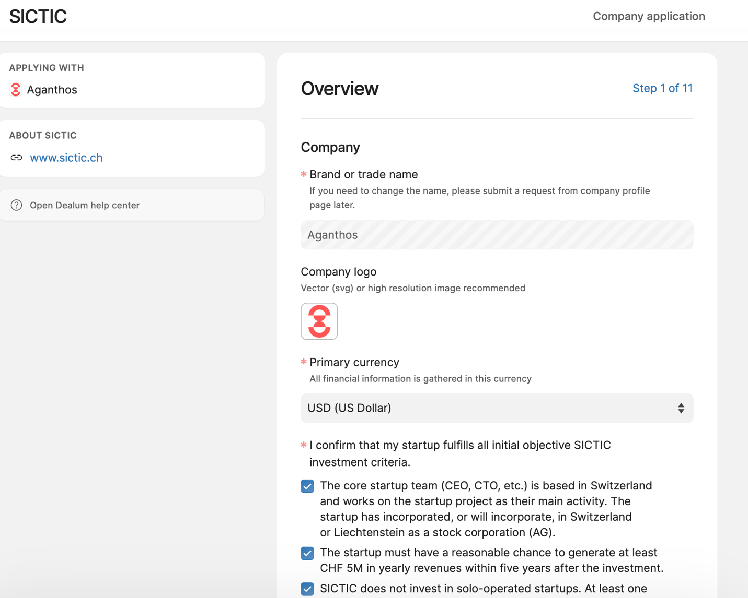
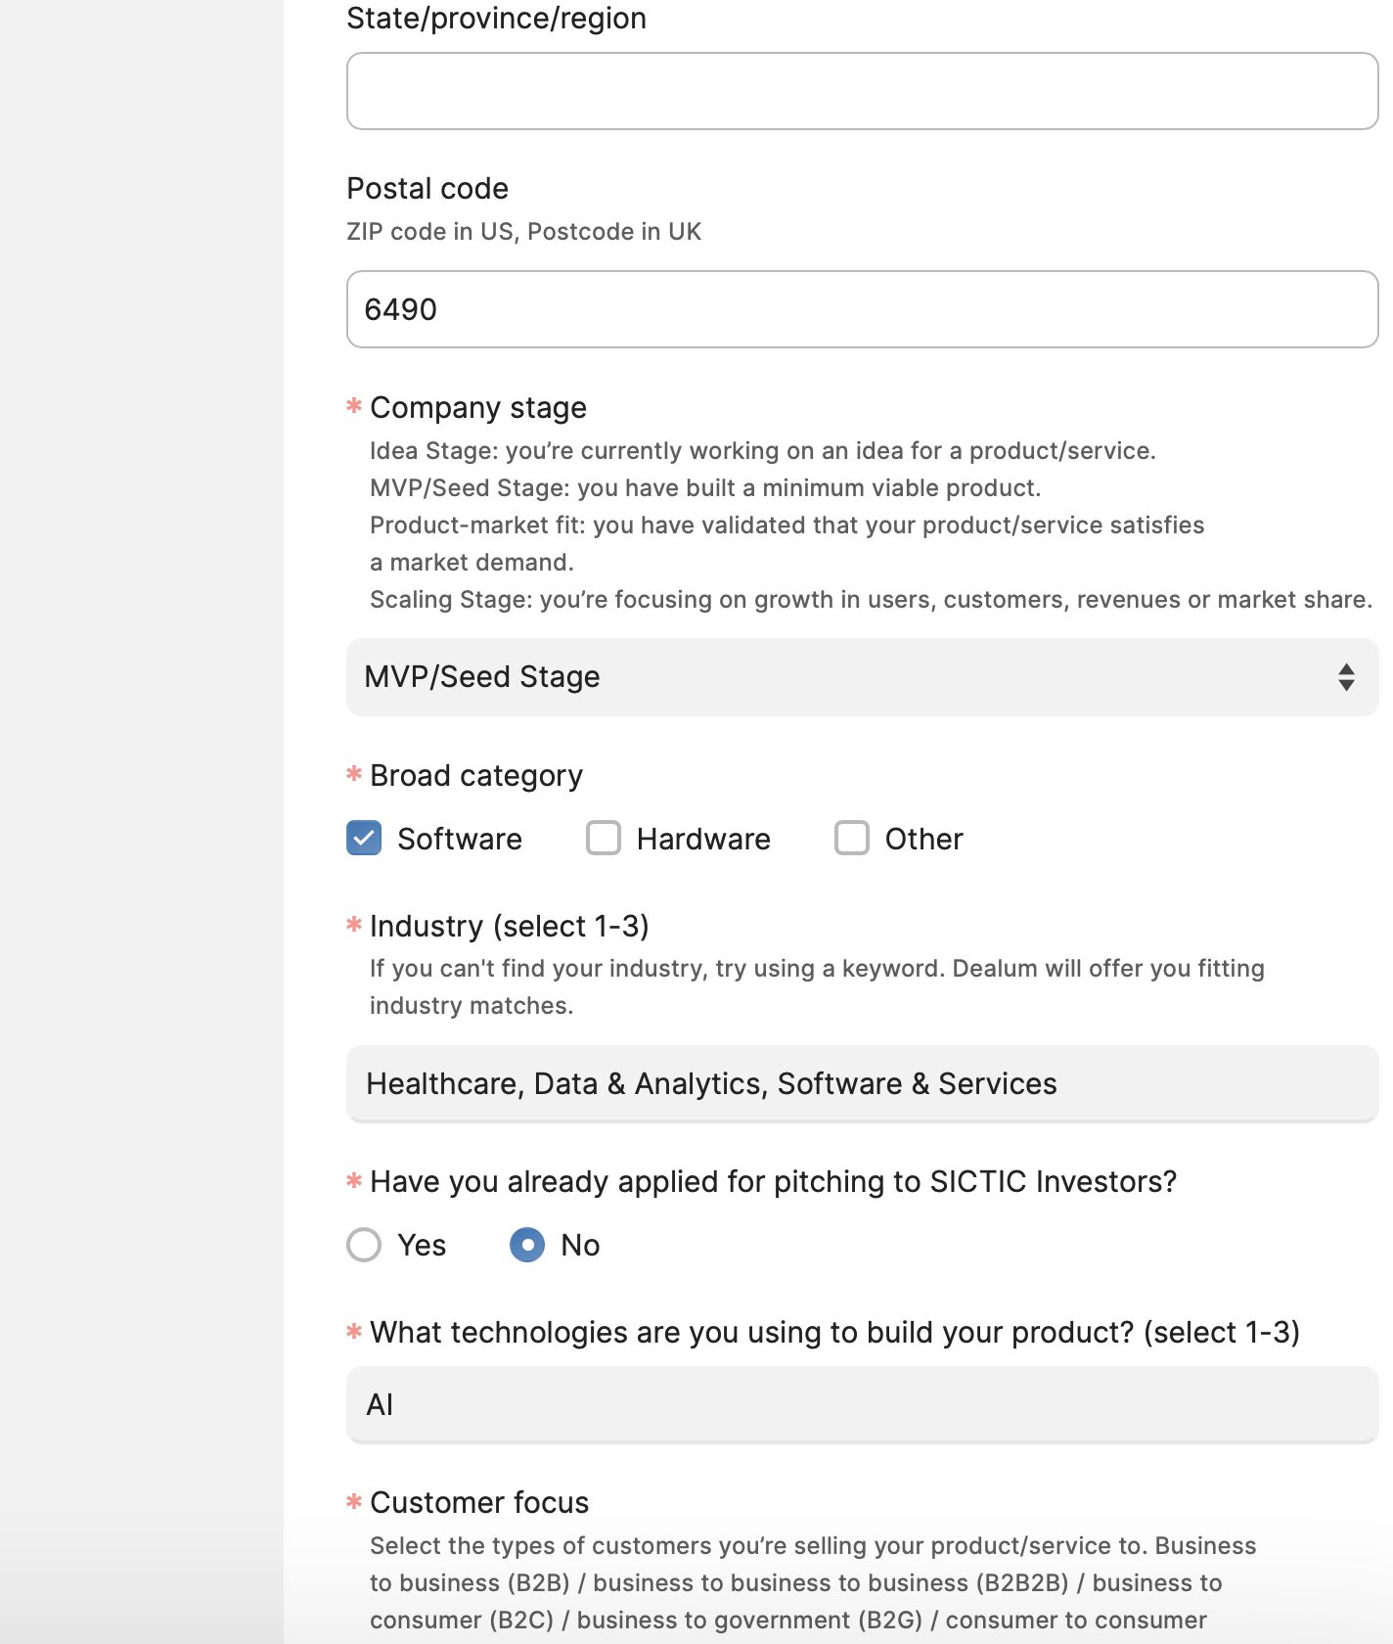
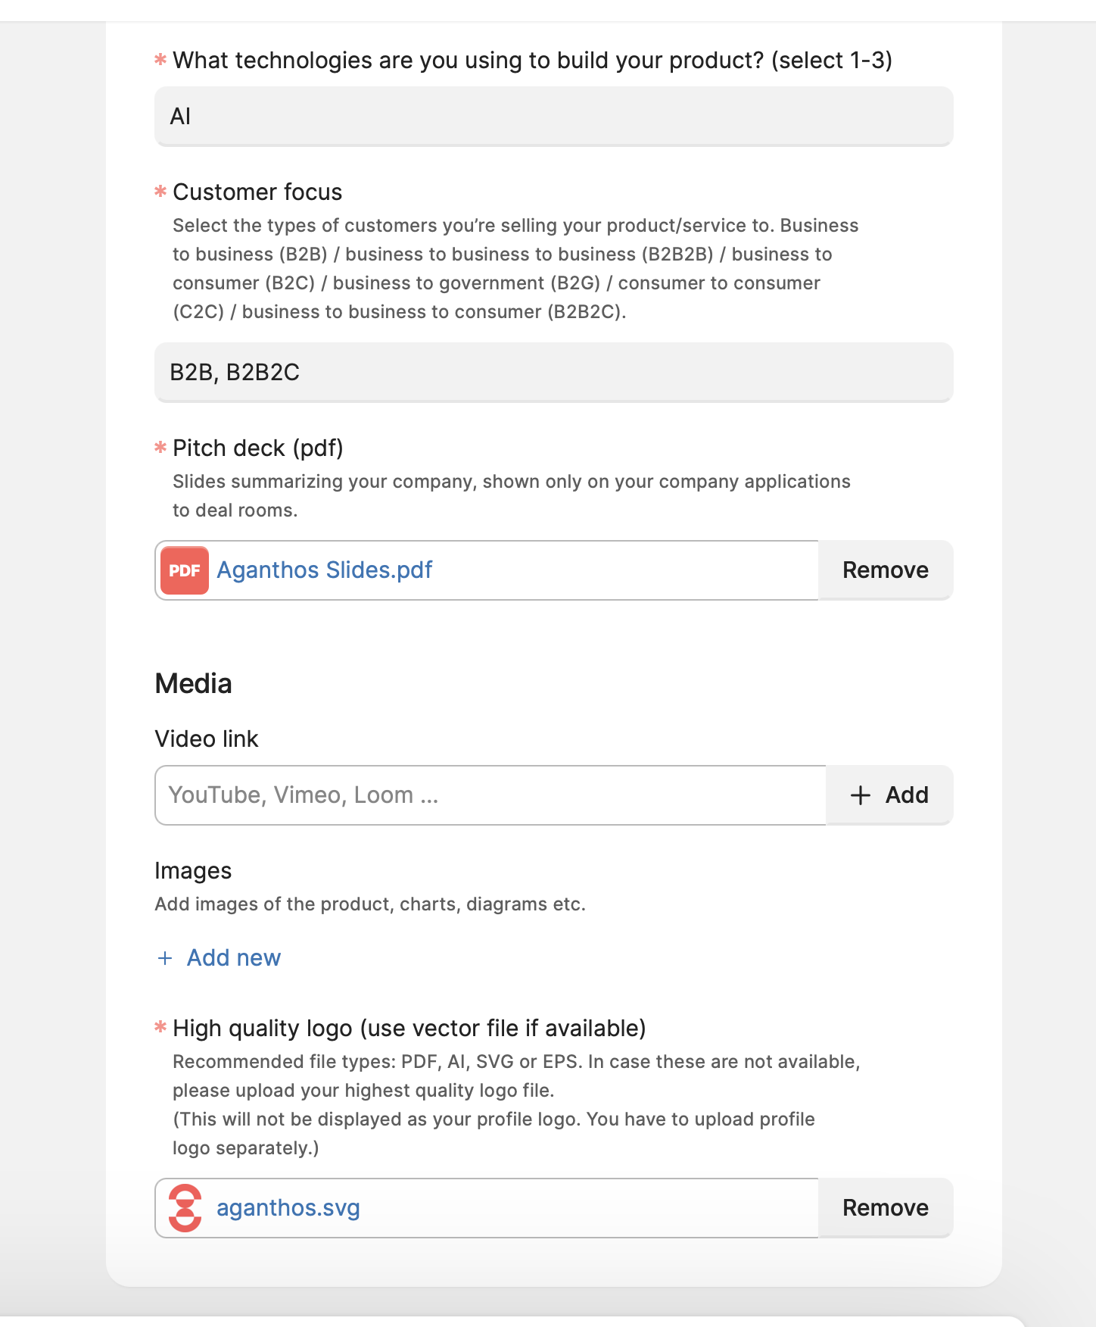
Relevant experience
Founder
- Design and implementation of a $2.6B national-scale crisis management team (building a 20-30 people team with high responsibility within a few months)
- Complex coordination and high-stakes decision-making across disciplines, sectors and levels
- Generative AI in Public Health/Medicine/Climate

Founder: Pioneering AI from Research to Impact
- A decade at the forefront of Reinforcement Learning (RL); AISTATS Best Paper nominee 2022
- From theory to high-impact application: games, high-speed robotics, electron microscopes, web agents and tool calling
- Founding Research Scientist at Convergence AI, leading the research team (Acquired by Salesforce in 2025)

Summarize the problem you're solving in 2-3 sentences.
Describe the customer problem you’re trying to solve with your product or service.

Tool-calling agents are currently often 'frozen,' unable to learn from errors or adapt to changing and specific organizational constraints. This results in brittle automation requiring manual maintenance. We solve this deficiency with a reinforcement learning feedback loop that converts failure logs into reliable, self-optimizing policies.

Solution

Describe your solution in a few sentences
Please explain in simple terms. Imagine that readers don't know anything about this subject. What is your company going to make? How does it solve the customer's problem?

Current AI agents are like employing a new intern every day. Aganthos is the 'training program' that fixes this. We feed back errors of the AI agents on day one into the improvement of the AI agent on day two - and so forth. This turns AI agents into experienced employees that become better over time, that learn and adapt to specific needs.

Summary of the customers and market in a few sentences
Who are your customers? Briefly describe your customers and users.

Our customers are B2B companies or companies with high margins deploying proprietary internal agents and potentially high-growth B2B SaaS platforms building autonomous workforce software (such as N8N).

Who are your customers and users in more detail?
Based on what characteristics do you decide who is and who isn't your customer?

We focus on customers hitting the 'Reliability Wall' of static AI uses, that is organizations running complex, tool-calling workflows that produce insufficient results and that break when underlying APIs or environments drift. We select customers based on three specific criteria:

High Action Volume: They must be executing stateful actions.
Cost of Failure: We target sectors with a high willingness to pay for Learning and dynamic AI infrastructure.
Architecture: Our ideal customer uses multi-step tool execution where reinforcement learning provides a measurable lift in quality and completion rates.

How did you estimate the market size?
Please specify link(s) to publicly available industry research or footnote references for market size estimate.
The improvement and maintenance of AI agent and AI orchestration platforms we are dedicated to is a part of the larger market of agentic systems(order of magnitude of 100s of billions in the coming years). Reinforcement learning will play a pivotal role in making these agentic systems reliable and dynamic.

"The global autonomous AI and autonomous agents market size was estimated at USD 3.93 billion in 2022 and is projected to reach USD 70.53 billion by 2030, growing at a CAGR of 42.8% from 2023 to 2030."
(https://www.grandviewresearch.com/industry-analysis/autonomous-ai-autonomous-agents-market-report)

"Gartner’s best case scenario projection predicts that agentic AI could drive approximately 30% of enterprise application software revenue by 2035, surpassing $450 billion, up from 2% in 2025." (https://www.gartner.com/en/newsroom/press-releases/2025-08-26-gartner-predicts-40-percent-of-enterprise-apps-will-feature-task-specific-ai-agents-by-2026-up-from-less-than-5-percent-in-2025)

What is your unique value proposition? What's new about what you're doing?
What features or benefits differentiate you from the competitors and existing solutions?

Our edge is Reinforcement Learning-for-tool-calling and tight adaptation to each organisation’s tools and constraints

Summarize the business model in a few sentences. How do you make money?
This is a summary for your short profile.

Agent and orchestration learning layer monetisation
1) Hourly setup fees
2) Maintenance fees and continuous improvement fees
3) Usage based tiers of trained model

Aganthos Joint Ventures
1) Equity + selling goods & services
2) Revenue share

Cost structure (customer acquisition cost, distribution costs, hosting, people)
Please outline the proportions of the main fixed and variable costs your project incurs.

Initial distribution anticipated:

People (Fixed ~50%): Our largest cost is high-caliber R&D talent and engineers required to build the core orchestration and training layer.
Hosting/Compute (Variable ~35%): We have high variable costs driven by GPU utilization for running Reinforcement Learning training loops and model fine-tuning; this is our primary scaling constraint.
CAC/Distribution (~15%): Customer Acquisition costs are focused on enterprise pilots addressing among others business development teams, though we keep distribution costs lean by ideally partnering with established agent platforms.

Explain in short, how is your business model scalable?

Our model decouples revenue from headcount by automating the maintenance of AI agents. Instead of hiring engineers to manually patch broken workflows, we utilize automated reinforcement learning loops that scale linearly with GPU compute, not human labor. Furthermore, our 'docking station' strategy targets high-volume agent platforms (B2B2B), allowing us to onboard thousands of end-users through single partnership integrations rather than massive direct sales efforts.

